**LIBRARY FEEDBACK MANAGEMENT SYSTEM**

**BY**

**IJAMY VINCENT SANDAJI**

**PA101/G/1590/15**

A project proposal submitted in partial fulfillment of the requirements for the award of the Degree of Bachelor of Science in Mathematics and Computer Science, Department of Pure and Applied Sciences, School of Pure and Applied Sciences of Kirinyaga University.

**November 2022**

# DECLARATION

I …………………………………………………………………………... hereby declare that everything in this project report is based on my knowledge and research carried out with the expectation to be printed or in electronic content and has not been submitted to any institution of learning for any academic awards. Signed……………………………………………………………. Date……………………………………………………………

# APPROVAL

This project proposal has been submitted in partial fulfillment of the requirements of the degree of Bachelor of Science in Mathematics and computer science at Kirinyaga University with my approval as the University supervisor.

Supervisor Name: Dr. JOSPHAT KARANI Signed……………………………………………………………. Date…………………………………………………………

# DEDICATION

I want to dedicate this work to my family, Kirinyaga University classmates, and friends who have been incredibly helpful while I've been working on this study project.

# ACKNOWLEDGEMENT

I would like to thank the Almighty God for seeing me through my entire degree program. He kept me strong physically, emotionally, and spiritually. Moreover, He also gave me the wisdom, knowledge, and understanding which enabled me to pursue my degree successfully.

I owe special thanks to Dr. Josphat Karani, from the school of Information Systems and Technology, who was also the supervisor of this project. He shared his vast experience and knowledge, providing the necessary guidance from the start to the end of this project. His advice enabled me to finish this project successfully.

I would like to thank Kirinyaga university for giving me a chance to do my studies at this great institution. The conducive environment has enabled me to come this far

Special thanks to my beloved mother, Mrs. Everlyne Mmbone for the unending love and support she has provided me throughout my entire life. Through her encouragement and constant prayers, I was able to come this far with my studies. I would like to thank the rest of my family members and my friends for their contribution to this project. Their advice was very helpful.

# ABSTRACT

Library feedback management system is a project which aims in developing a computerized system to maintain all the daily work of the library and some additional functionalities to help students and teachers interact. This project has many features which are generally not available in normal library management systems like the module that allows students to rate books and give the librarian information about the more relevant books they need to buy. It also has a facility for admin login through which the admin can monitor the whole system. It has also a facility where students after logging in to their accounts can see a list of books issued, their issue date, return date, and also the students can request the librarian to add new books by filling out the book request form. The librarian after logging into his account I.e admin account can generate various reports such as student report, issue report, teacher report, and book report Overall this project is being developed to help the students as well as the staff of the library to maintain the library in the best way possible and also reduce the human efforts.

Table of Contents

DECLARATION i

APPROVAL ii

DEDICATION iii

ACKNOWLEDGEMENT iv

ABSTRACT v

List of tables viii

List of Figures ix

CHAPTER ONE: INTRODUCTION 10

1.1 INTRODUCTION 10

1.2 BACKGROUND AND MOTIVATION 10

1.3 CURRENT/EXISTING SYSTEM 11

1.4. PROBLEM STATEMENT 11

1.5 PROPOSED SYSTEM 12

1.6 PURPOSE OF THE STUDY 12

1.7. GENERAL OBJECTIVE 12

1.8 SPECIFIC OBJECTIVES 12

1.9 JUSTIFICATION 13

1.10 SCOPE 13

1.11 LIMITATION 13

1.12 SIGNIFICANCE OF THE STUDY 13

CHAPTER TWO: LITERATURE REVIEW 14

2.1. INTRODUCTION 14

2.2. A Look at Automation of Libraries in Institutions of Learning 16

Three officially recognized National Centers were established in Kenya to play a vital role in the organization of training events and support trainees who are engaged in digitization projects or creating Greenstone digital library apps. By integrating information technology into libraries, these initiatives hope to increase access to academic materials for all people worldwide. 18

2.3 Functionalities of Library Feedback Management Systems 18

2.4 Challenges facing Library Feedback Management Systems 18

2.5. Conclusion 19

CHAPTER THREE: SYSTEM DEVELOPMENT 20

3.1 INTRODUCTION 20

3.2 SYSTEM DEVELOPMENT METHODOLOGY 20

3.2.1 WATERFALL MODEL 20

3.1.2 STEPS IN THE WATERFALL MODEL 21

3.3 JUSTIFICATION 25

3.4 DATA COLLECTION 25

3.5 DATA ANALYSIS 25

3.6 CONCLUSION 26

CHAPTER FOUR: SYSTEM DESIGN 27

4.0 Introduction 27

4.1 process diagram 28

4.1.1 Login flow diagram 28

4.1.2 Use case diagram 29

4.1.3 Process flow diagram 31

4.1.4 Input design 31

4.1.6 Database 33

4.2 CONCLUSION 33

CHAPTER FIVE: SYSTEM IMPLEMENTATION AND TESTING 1

5.1 Introduction 1

5.2 login page 1

5.3 Admin main dashboard 2

5.4 cashier dashboard 3

5. 9 Conclusion 7

CHAPTER SIX: CONCLUSION RECOMEDATION AND FUTUREWORK 8

6.1 CONCLUSIONS 8

6.2 RECOMMENDATION 8

6.3 FUTURE WORK 8

# List of tables

Budget Table…………………………………………………………………21

Duration Table ……………………………………………………………….22

Gantt chart…………………………………………………………………….23

# List of Figures

Waterfall diagram…………………………………………………13

System design diagram ……………………………………………15

# CHAPTER ONE: INTRODUCTION

## 1.1 INTRODUCTION

This chapter will have the background information, current operating system, problem statement, proposed system, the purpose of the study, objective of the study, justification, scope, limitation, and significance of the study.

## 1.2 BACKGROUND AND MOTIVATION

Accelerated technological advancements experienced in the 21st century have enabled the automation of services delivered to people across the globe. Currently, many libraries have embraced the trend of automating their services by providing rich electronic resources for research and other purposes to the public. Library Feedback Management System is an application that applies different techniques that can generally be used in a small or medium-sized institution. It is used by a librarian to manage the library using a computerized system where he/she can record various transactions like the issue of books, the return of books, the addition of new books, the addition of new students, etc. Books and student maintenance modules are also included in this system which would keep track of the students using the library and also a detailed description of the books a library contains. With this computerized system, there will be no loss of book records or member records which generally happens when a noncomputerized system is used. In addition, the library will stock more relevant books because of feedback they get from students and lectures. Students will also be able to borrow more relevant books because they will be able to inquire from fellow students and lecturers and also by checking book ratings.

If the user's position is admin, the user can generate different kinds of reports like lists of students registered, lists of books, and I, issue and return reports. All these modules can help librarian to manage the library with more convenience and in a more efficient way as compared to library systems which are not computerized.

In addition, students can view the list of available books and reserve any book in advance so that it can be made available in time for the student. The student can check the due date and be able to return the book in time.

My motivation to develop this system came from the increased need to access resources over the internet for purposes of research, increased information technological advancements that enable service automation, and the government’s drive to digitize resources for extensive research in both public and private universities. I have acquired vast knowledge at Kirinyaga university that has motivated me to develop a system that addresses this problem.

## 1.3 CURRENT/EXISTING SYSTEM

The majority of libraries, particularly those in higher education institutions, are computerized, but they don't have a feedback module or a way for students and lecturers to communicate about which books are the most pertinent to them. Additionally, the existing module does not give students the choice to tell the librarian which books are more pertinent to them. Additionally, based on their opinions of the books, the students will grade them on a scale of 1 to 5.

## 1.4. PROBLEM STATEMENT

It gets tiresome for a student to stay in a line waiting to be issued a book that he/she would have reserved earlier. This also wastes time that a student would have rather used to study. It is also frustrating to wait in line for a long time only to discover that the book that you wanted to borrow is unavailable. It's also not a best practice for a student to go and pick any book in the library yet he/she can inquire from lecturers and fellow students. The management finds it difficult to keep track of statistical information about the daily transaction taking place in the library, making report writing and accounting very difficult. As a result, an incorrect conclusion will be drawn.

## 1.5 PROPOSED SYSTEM

The library feedback management system will be able to track daily library usage. The teacher will be able to know the kind of books his/her students uses and can advise accordingly on which the student can use to improve his/her performance. All the stock available in the library will be available in the system and it will be easy to monitor to know when the library needs to be restocked. All information regarding the library will be secure because every person will only be able to see what concerns him or her.

## 1.6 PURPOSE OF THE STUDY

The purpose of the study is to ensure the effective and faster operation of a library as the technology continues to evolve dynamically.

## 1.7. GENERAL OBJECTIVE

The purpose of the study is to develop a library feedback management system that will enable the librarian to get information from lecturers and students without meeting physically

## 1.8 SPECIFIC OBJECTIVES

1. To develop a module that will capture and store books and students’ details
2. To create a module that will allow lecturers and students to notify the librarian of the best books they can stock.
3. To create a system that will allow students to rate books.

## 1.9 JUSTIFICATION

This system has been developed after doing extensive research about the existing library systems and the gaps that need to be filled. This project is here to address these gaps.

## 1.10 SCOPE

This research is limited to automating some functions of a library management system. The project is just limited to enabling reserve books and being able to rate them and notify the librarian of the best books they can stock.

## 1.11 LIMITATION

Several limitations were encountered. They include; the time given to complete the project was limited given that the researcher had another task to perform on the side. Learning new technologies to come up with a good system also took part in the system development time.

## 1.12 SIGNIFICANCE OF THE STUDY

This project is going to be of benefit to many libraries that will adopt it. It will simplify work and reduce queuing at their libraries. It will also enhance social distancing that’s being exercised to reduce the spread of COVID-19.

# CHAPTER TWO: LITERATURE REVIEW

## 2.1. INTRODUCTION

The research and development of library feedback management systems, as well as the diverse methodologies employed by these systems, are covered in this chapter. To give knowledge on this subject, online journals, papers, publications, and books were employed. People congregate in libraries all over the world because they offer a comfortable setting for research and learning. The vast majority of these libraries are found inside educational institutions. These libraries are crucial to an institution's overall functioning.

(Chweh S.S, 1981) In his journal titled “User criteria for evaluation of library service” outlined the features of a good library. These include the availability of periodicals, a good collection of reference material, non-book materials and books, the quality of reference services delivered, a quiet environment for studying, catalog integrity, how services are friendly, and the willingness of librarians to help.

To enhance the level of service provided to its patrons, the library developed the Feedback Management System. This is made possible by automating various library functions, including the ability for patrons to reserve books and advise the librarian and administration on the best books to stock. The system was created after a legacy system evaluation, which did not permit students to reserve books, rate books, or ask fellow students or the lecturer about any library-related information. To identify the necessary relevant functionality, user needs were gathered. This review was used as a management tool to assess how well services were provided to library patrons, to pinpoint the system's drawbacks, and to determine the most effective.

By pressing a pedal that spun a book table, the French book wheel invention allowed academics to move books around. In the 1930s, libraries started automating. At this time, the management of book purchases and circulation was handled via punch card systems.

(Gapen, 1993) Note that a virtual library includes the capability of remotely accessing the services and information of other libraries, in addition to other sources of knowledge. The internet serves as a useful tool for making information accessible to anyone in the world for sharing and access. Libraries have gathered materials that can be a reliable source of knowledge for study and other purposes. It is highly advantageous to make these extensive resources available to the general population worldwide. The goal of technological development is to simplify tasks and assure efficiency in all areas of life where it can be used.

(Roberts, 1999) A Librarian at Cohen Hillel Academy points out that after automating their library services; the electronic catalog was faster, more versatile, and easier to use than the old card catalog which they used before automation. The new system encouraged both students and teachers to do more research by utilizing the resources offered. The librarian notes that the school library had only automated its circulation functions which made use of older circulation software. They used this program till 1998 when they decided to upgrade to the Follett Software Company’s Circulation Plus and Catalog which was computerized. She notes that to motivate the library staff their workload must be simplified and the technology used by the school streamlined.

(Aswal, 2006) Observes that library automation is the process of integrating systems to enable the sharing of information across networks, giving users all over the world access to substantial amounts of content and information. There has been a lot of emphases placed on using the internet and networking. The use of a library in the twenty-first century requires the most modern technology, therefore organizations must phase out outdated systems and adopt automation for all of their services.

(2004) Johnson, Houda, and Tony It should be noted that a virtual library can connect online learners to licensed databases with a wealth of resources, public library catalogs, and learning and research materials. With an internet connection, users can browse these virtual libraries from anywhere in the world at any time. Since the Library Feedback Management System intends to supply automated services and user interaction between users efficiently and effectively via the internet, the system's adoption offers significant benefits to the end users.

## 2.2. A Look at Automation of Libraries in Institutions of Learning

The development of library management systems has accelerated recently. These technologies make it quick and easy to find materials, which reduces search time. They enable everyone to have access to information that was previously only available to a small number of people. They also help preserve content that could otherwise degrade. Databases include original papers that have been digitally recreated.

(1999 Roberts) The old card catalog they utilized before to automation was slower, less flexible, and more difficult to use, according to the librarian at Cohen Hillel Academy. The new method encouraged instructors and students to perform more research using the resources at their disposal. The librarian notes that the school library had merely automated its antiquated circulation software-dependent circulating procedures. Up until 1998, when they decided to switch to the automated Circulation Plus and Catalog from the Follett Software Company, they continued to use this program. She makes the point that the workload of the library staff must be decreased, and the school's technology must be streamlined, in order to maintain their motivation.

This system offered the following benefits:

a. It made resources more accessible and sparked interest in the library. Users and employees found electronic resources more quickly as a result of this.

b. It demonstrated user-friendly technology, with the windows platform being simple to use and requiring little training. The materials were easier to find, and work was completed quickly.

c. Reports could be produced quickly, giving library employees the chance to efficiently oversee library operations.

d. The system presented a consistent learning environment and ease of maintenance.

The majority of Kenya's libraries are located at research institutes, as well as public and private educational institutions. Public universities house the majority of books, journals, research papers, and other resources. The libraries were constructed primarily for use by the school's faculty, staff, and students. The library's administration has collaborated to restructure its offerings such that non-regular users can now access them. Several libraries are creating information resource centers to embrace technology.

(Amollo, 2011) The following points highlight the importance of digitizing libraries:

i. It enhances and expands access to electronic collections created by other digital libraries.

ii. It prolongs the useful life of knowledge.

iii. It promotes and makes resource sharing between libraries around the world easier.

iv. It minimizes work duplication.

2011 (Amollo) identifies several projects aimed at Kenya's libraries being digitalized. One of these initiatives is the Greenstone digital library program, created by UNESCO in 2008 and hosted at the University of Nairobi (UoN). In order to broaden the network and build expertise, Electronic Information for Libraries joined with The Koha Foundation when Greenstone, a suite of tools for developing and distributing digital library collections in South Africa, was released in 2007. In 2009, this organization's geographic reach was expanded to sixteen countries, including Kenya.

## Three officially recognized National Centers were established in Kenya to play a vital role in the organization of training events and support trainees who are engaged in digitization projects or creating Greenstone digital library apps. By integrating information technology into libraries, these initiatives hope to increase access to academic materials for all people worldwide.

## 2.3 Functionalities of Library Feedback Management Systems

This Library Feedback Management system has come up to integrate several functionalities. These include:

* Capture and store book details.
* Allow students and lecturers to request the library to buy essential books.
* Allow students to rate books
* Allow interaction between students, lecturers, and librarians.
* Sending users reminders on reservations.

## 2.4 Challenges facing Library Feedback Management Systems

Libraries are faced with several challenges when it comes to automating some of their services. Some of these reasons include:

* Lack of sufficient funds to support the entire automation process.
* Lack of facilities to run the automated software program.
* Lack of manpower with adequate skills to handle the systems.

Several problems that arose during the development of institutional repositories were mentioned by (Otando, 2011). There are a number of issues with the systems, including insufficient staffing and a lack of technical specialists, limited support from the highest levels of institution management, a lack of awareness, insufficient funding for the systems, and a lack of prioritization of institutional repositories within library systems. Institutions can overcome these issues by heeding the above-mentioned guidelines.

## 2.5. Conclusion

Access to a range of library materials is made simpler by the Library Feedback Management System, which increases user understanding. Since information should be shared, this system provides a platform for all of its users to access an abundance of online material resources, fostering an environment where everyone may benefit from one another's knowledge. If the book is late, the system is likewise reasonably priced. In order to provide and enhance a beneficial environment for learning and research, libraries should automate every function they give to their end users.

# CHAPTER THREE: SYSTEM DEVELOPMENT

## 3.1 INTRODUCTION

This chapter looks at the system development life cycle, such as the set of methodical processes, activities, and phases used to develop and implement this proposed system to achieve the desired goal.

## 3.2 SYSTEM DEVELOPMENT METHODOLOGY

Systems development methodology (SDM) is a standard process followed in an organization to conduct all the steps necessary to analyze, design, implement and maintain information systems. It is highly beneficial for organizations to adopt a systems development methodology to develop IS. For the Library Feedback Management System, I used the waterfall methodology.

### 3.2.1 WATERFALL MODEL

With a waterfall technique, requirements from customers and stakeholders are gathered at the start of the project, after which a sequential project plan is made to take those requirements into account. Because each project phase flows into the next, following steadily downward like a waterfall, the waterfall model is so named.

It is a thorough, organized system that has been used for a very long time because it is effective. Construction, IT, and software development are a few fields that frequently employ the waterfall paradigm. As an illustration, software engineering projects are frequently managed using the waterfall software development life cycle, or waterfall SDLC. The first SDLC methodology for software development was the waterfall model. The waterfall Model illustrates the software development process in a linear sequential flow. This means that any phase in the development process begins only if the previous phase is complete. In this waterfall model, the phases do not overlap as in figure **3.1** below

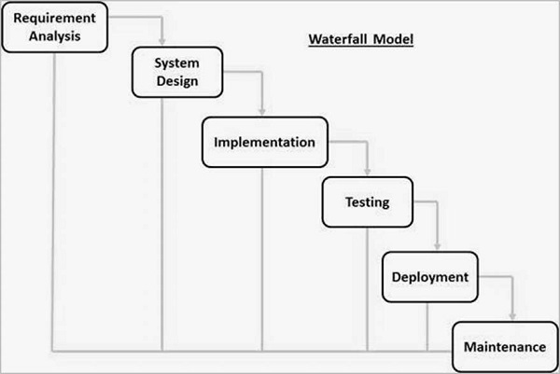

Figure 3.1.2

### STEPS IN THE WATERFALL MODEL

1. **Requirement analysis: -** First, I had to gather all the requirements and documentation I needed to get started. They include:
   * + **Project Scope:** This is one of the most important documents in your project, where you determine what the goals associated with building your app are: functional requirements, deliverables, features, deadlines, costs, and so on.
     + **Stakeholder Expectations:** To align the project scope with the expectations of your stakeholders—the people who have a vested interest in the development of the app—you want to conduct interviews and get a clear idea of exactly what they want.
     + **Research:** To better serve your plan, do some market research about competing apps, the current market, customer needs, and anything else that will help you find the unserved niche your app can serve.
     + **Assemble Team:** Now, you need to get the people and resources together who will create the app, from programmers to designers.
     + **Kickoff:** The kickoff meeting is the first meeting with your team and stakeholders where you cover the information you’ve gathered and set expectations.
2. **System Design** − the requirement specifications from the first phase are studied in this phase and the system design is prepared. This system design helps in specifying hardware and system requirements and helps in defining the overall system architecture. In this section, the requirements are translated into a detailed design and flowchart of the software code am creating.

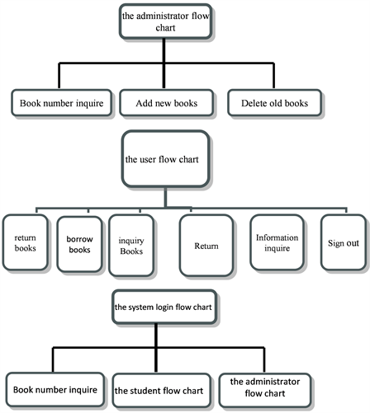

Figure 3.2 (**design system**)

1. **Implementation** − with inputs from the system design, the system is first developed in small programs called units, which are integrated into the next phase.

For this phase, ReactJS is used for the front end, React-Bootstrap for styling, NODEJS for the back end, and MongoDB as the preferred database. Visual Studio Code is the preferred IDE for development.

* 1. **Integration and Testing** − All the units developed in the implementation phase are integrated into a system after the testing of each unit. Post integration the entire system is tested for any faults and failures. System testing consists of three different kinds of testing activities as described below :
     + 1. **Alpha testing:** Alpha testing is the system testing performed by the development team. I’ll do this testing by myself as I develop.
       2. **Beta testing:** Beta testing is the system testing performed by a friendly set of customers.
       3. **Acceptance testing:** After the software has been delivered, the customer performed acceptance testing to determine whether to accept the delivered software or reject it.

1. **Deployment of system** − Once the functional and non-functional testing is done; the product is deployed in the customer environment or released into the market. There are several types of deployment but I’ll use parallel deployment as it allows several online deployment operations to run simultaneously. As a result, it scales deployments in an AS Java Cluster and improves the performance of the online deployment operations.
2. **Maintenance** – Some issues come up in the client environment. To fix those issues, patches are released. Also to enhance the product some better versions are released. Maintenance is done to deliver these changes in the customer environment.
3. **Corrective Maintenance:** This type of maintenance is carried out to correct errors that were not discovered during the product development phase.
4. **Perfective Maintenance:** This type of maintenance is carried out to enhance the functionalities of the system based on the customer’s request.
5. **Adaptive Maintenance:** Adaptive maintenance is usually required for porting the software to work in a new environment such as working on a new computer platform or with a new operating system.

## 3.3 JUSTIFICATION

I chose the waterfall model because its an idealistic model for software development. It’s the simplest model which is very easy to understand. Phases in this model are processed one at a time.Each stage in the model is clearly defined and the processes, actions, and results are very well documented.

It reinforces good habits: define-before-design, design-before-code.

This model works well for smaller projects and projects where requirements are well understood.

## 3.4 DATA COLLECTION

The main aim of data collection was to get quality data rather than quantity. For this reason, only one method was more suitable for participant observation to get direct phenomena.

The process involves observing and studying the spontaneous behavior of the participants in open or natural surroundings. The role of the researcher is to find and record whatever he can see and observe in the natural habitat.

## 3.5 DATA ANALYSIS

This is a process of inspecting, cleaning, transforming, and modeling data to discover useful information, inform conclusions, and support decision-making. Data analysis has multiple facets and approaches, encompassing diverse techniques under a variety of names, and is used in different business, science, and social science domains.In today's business world, data analysis plays a role in making decisions more scientific and helping businesses operate more effectively. I did a Prescriptive analysis with one question in mind; what should I do?

## 3.6 CONCLUSION

This chapter begins with an introduction to the system development life cycle and how its deployed in this project. System development methodology proceeds to the SDLC phase. In collecting data, library and online research are used. For online research, the qualitative method is chosen in which a group of journals is used in the research procedure.

# CHAPTER FOUR: SYSTEM DESIGN

## 4.0 Introduction

This chapter describes the proposed system's structural layouts. The flow of activities and the actors participating in the project are clearly shown in a process flow diagram and a use case diagram. This chapter describes the proposed system's structural layouts. The actors participating in the project's activities are clearly shown in a process flow diagram and a use case diagram.

## 4.1 process diagram

### 4.1.1 Login flow diagram

Password and username dont match

Enter username and password

If password and username

Correct

If user

If admin

Admin Dashboard +

HOMESCREEN

The login information needed to access the management system for the library is shown in the above figure. While entering login information, one must use the correct username and password; otherwise, the system returns you to the login screen.

### 4.1.2 Use case diagram

A use case diagram is a visual representation of potential user interactions with a technology. Often accompanied by other types of diagrams, a use case diagram displays various use cases and various user types the system has.

**Admin user case**

UPDATE Book

INFORMATION

VIEW REPORTS

Issue Books

ADD ITEM/REMOVE

Books

**Normal user case**

CHANGE PASSWORD

RESERVE A BOOK

REVIEW A BOOK

RATE A BOOK

### 4.1.3 Process flow diagram

USER DEATILS

ADMIN

4.1.4 Input design

REPORT

INVENTORY

OUT OF STOCK BOOKS

DUE BOOKS

RESERVATIONS

BOOK DETAILS

NORMAL USER

PRODUCT

HOMESCREEN

ADMIN DASHBOARD

LOG OUT

RETURN DATE

CATEGORY

AVAILABILITY

Add to cart

RESERVATIONS

The input design entails the information and data in the system.

**Registration Form**

EMAIL ……………………………

USERNAME ………………………

PASSWORD ………………………

CONFIRM PASSWORD…………………

**4.1.5 OUTPUT DESIGN**

Login output:

**Admin/User**

Email …………………………………….

Password ……………………………………..

**Product output design**

Book Title ……………………………………

Author ……………………………………..

CoverImage …………………………….

Category ……………………………

Count in Stock ………………………………..

### 4.1.6 Database

Product database

|  |  |  |  |  |  |  |
| --- | --- | --- | --- | --- | --- | --- |
| TITLE | AUTHOR | CATEGORY | DESCRIPTION | RATING | REVIEW | QUANTITY |
|  |  |  |  |  |  |  |

**User database**

|  |  |  |  |
| --- | --- | --- | --- |
| USERNAME | EMAIL | isAdmin | PASSWORD |
|  |  |  |  |

**Reservation database**

|  |  |  |  |
| --- | --- | --- | --- |
| TITLE | DATE TAKEN | RETURN DATE | USER |
|  |  |  |  |
|  |  |  |  |

## 4.2 CONCLUSION

The various designs ranging from input design to the output design ensures a timely completion of the implementation process

# CHAPTER FIVE: SYSTEM IMPLEMENTATION AND TESTING

## 5.1 Introduction

The Library Feedback Management System was created using Visual Studio code and adhered to the three tier application architecture. It gave us access to the solution explorer, which was a white blank space, and the code editor, which contained all of the code files. The logical were developed into code and kept safe in the solution in the code editor.

## 5.2 login page

To log into the system, administrators or norma user must enter the proper username and password in the designated fields on the login page

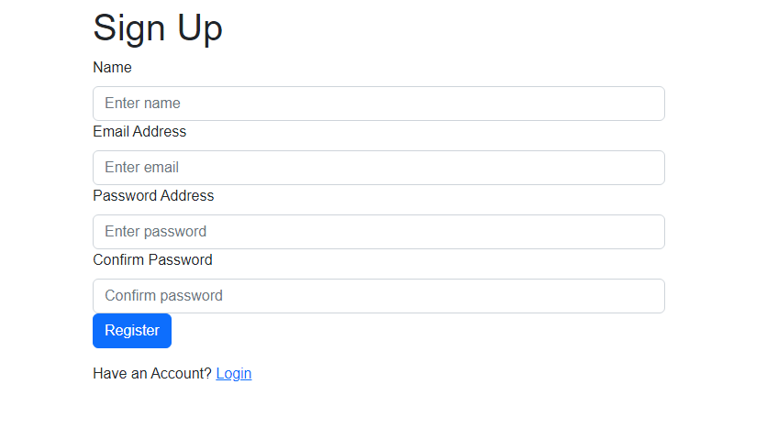

.When password and username do not match, the user cant login into the system and the following error is generated

## 5.3 Admin main dashboard

Every action that the administrator does is shown on the dashboard. A new user can be added, a new product can be added, updated, or deleted. Also a book can be issued and a report generated

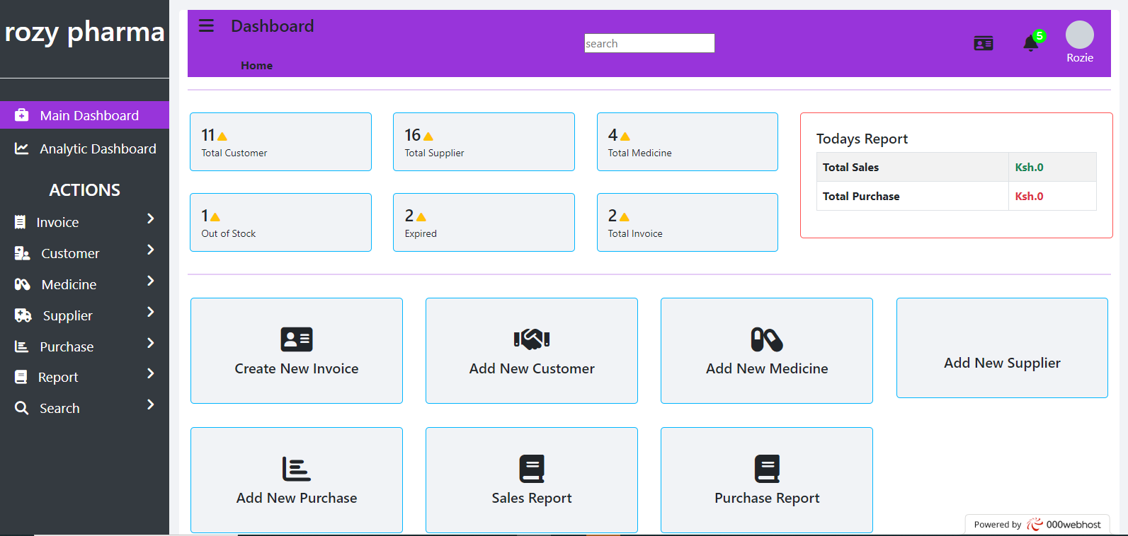

## 5.4 normal user homescreen

The user can browse through a collection of books, choose the desired one and give it a review. The user can also place the book on the cart with an option of reserving it and picking it later for three days.

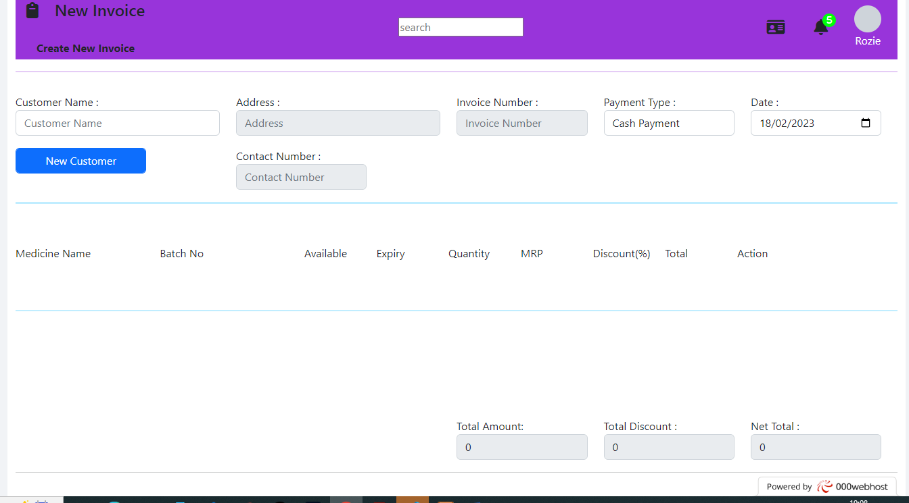

5.5 Adding new customer

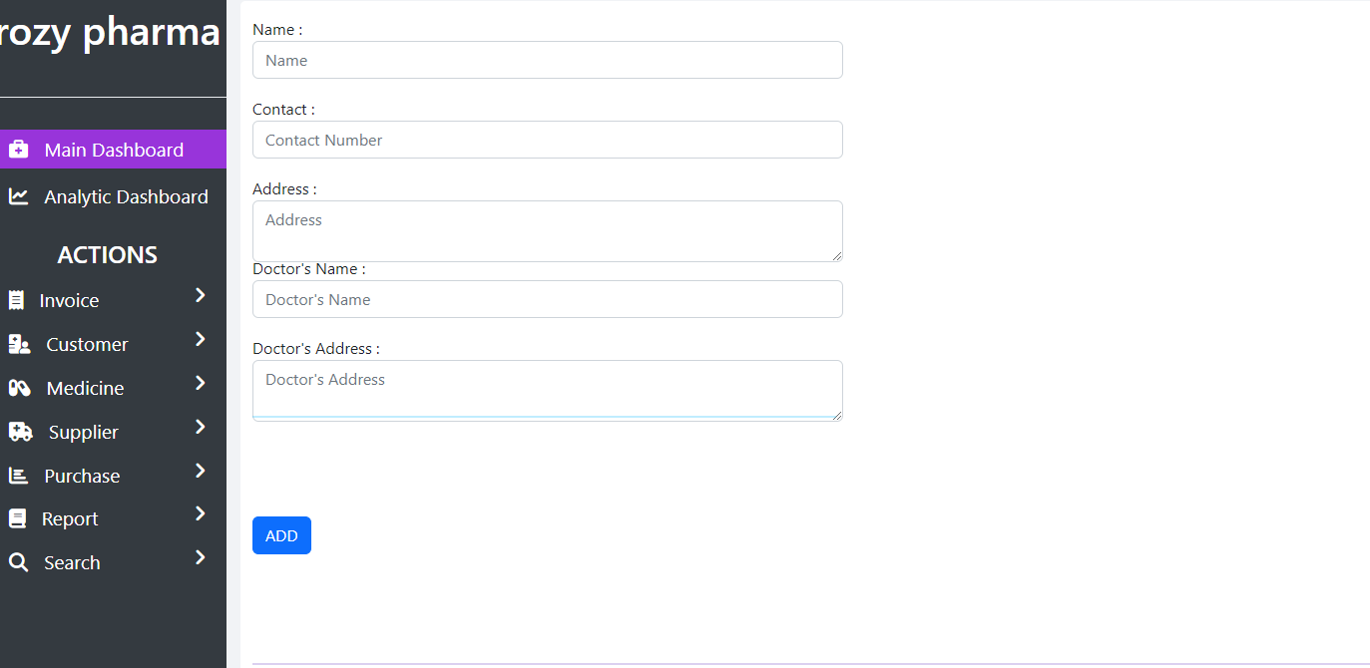

5.6 Managing existing users

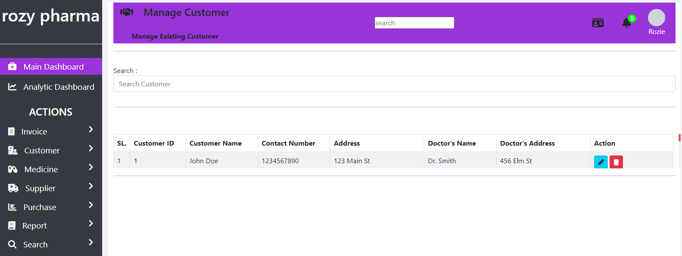

## 5.7 Adding new books

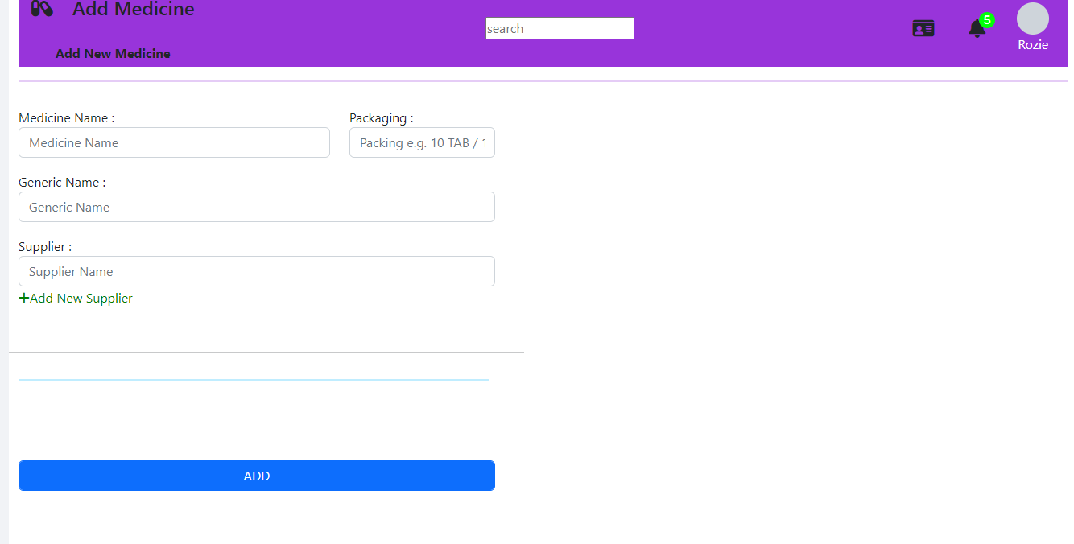

## 5.8 UPDATING BOOK DETAILS

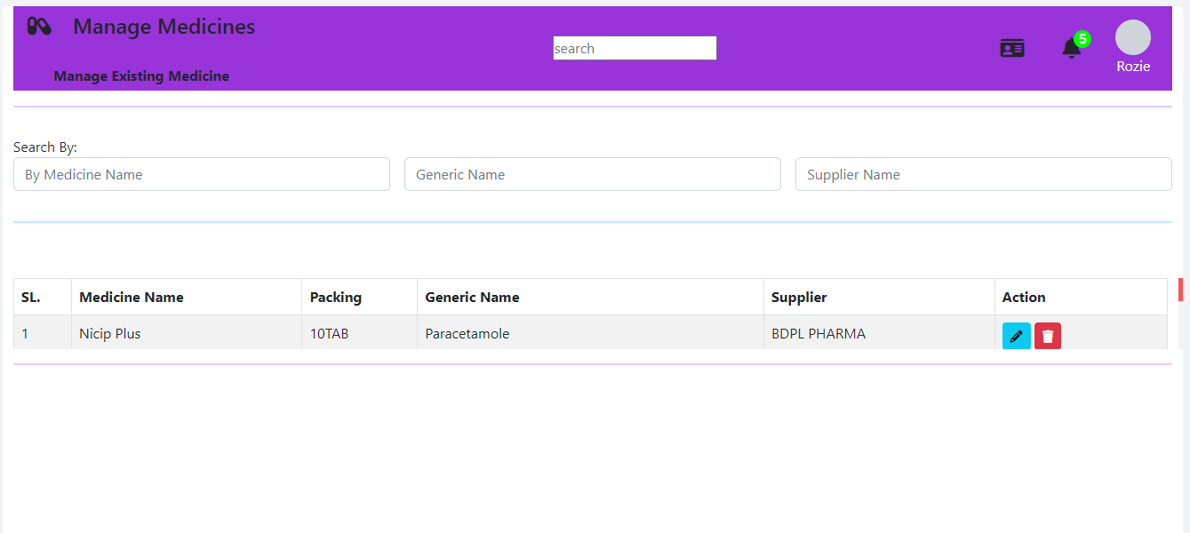

## 5.9 ISSUING NEW BOOKS

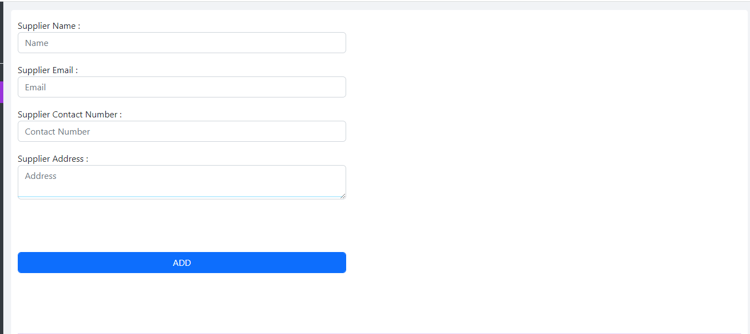

5.10 Sales report

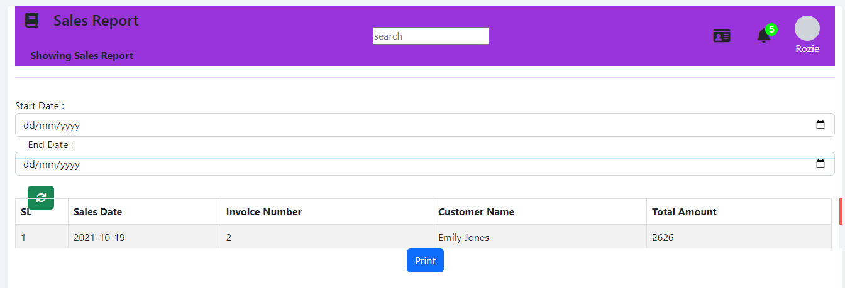

## 5. 9 Conclusion

Having done the implementation and testing of the system, it was found that the system is up and running and that the modules are well integrated to walk together. Also the system was well accepted by the users in that it’s easy to use and quick in processing services.

# CHAPTER SIX: CONCLUSION RECOMEDATION AND FUTUREWORK

## 6.1 CONCLUSIONS

This study will help the library users to be served faster, it will thus reduce long queues and congestion in the at the library. It will also help the admin to track daily transactions of the library, maintain the stock levels, and easier management. Also it will be very important to education institutions and in particular department of higher education in delivery quality services that will enhance user satisfaction.

## 6.2 RECOMMENDATION

Since we are in a digital era, researcher would like to recommend both governmental and private institutions to adopt this system to help simplify their operations in terms of customer services and record management.

## 6.3 FUTURE WORK

The following are some of the noted improvements that can be made on the system in the future.

* Incorporate a payment gateway so that former students can borrow books at a minimum fee.
* Incorperate a module that will see door to delivery incase the library user can be able to reach the library.

**REFERENCES**

• Aggarwal, K.K., & Singh, Y. (2007). Software Engineering (3rd Ed.). New Age International Publishers.

• Alison Felstead. (2004). “Library systems marketplace: a digest of current literature” Program: electronic library and information systems.

• Amollo, B. A. (2011). “Digitization for libraries in Kenya”. 2nd International Conference on African Digital Libraries and Archives. URL:http://www.slideshare.net/bamollo/digitization-for-libraries-in-kenya

• Aswal, R.S., (2006). “Library Automation for 21 Century”. New Delhi: Ess Ess Publication.

• Chweh, S. S. (1982). “User criteria for evaluation of library service”. Journal of Library Administration, 2(1), 35-46.

• Gapen, D. K. (1993). “The virtual library: Knowledge, society and the librarian.” In The Virtual Library: Visions and Realities, edited by L. M. Saunders, pp.1-14. Information Today, Medford, NJ.

• IEEE Standards 1016-1998, Recommended Practice for Software Design Descriptions

• IEEE Standards 830-1998, IEEE Recommended Practice for Software Requirements Specifications.

• Johnson, K., Houda, T., & Tony T. (2004). “Library Support for Online Learners: e-Resources, e-Services, and the Human Factors.” In Theory and Practice of Online Learning, edited by Terry Anderson and Fathi Elloumi. Athabasca, Alberta: Athabasca University, 349-365.

• Otando, R. M. (2011). Building Institutional Repositories in KLISC Member Institutions in Kenya: Current Status and Emerging challenges.

• Pressman, Roger S. (2000) “Software Engineering: A Practitioner’s Approach”, (5th Ed.). McGraw-Hill.

• Roberts, P. (1999). “Students Books reclaim priority status at the library”. Marblehead Massachusetts.

**APPENDICES**

**APPENDIX 1: BUDGET**

**Table 1**

|  |  |  |
| --- | --- | --- |
| **NO** | **ITEM** | **COST** |
| 1 | LAPTOP | KSH 35000 |
| 2 | INTERNET BUNDLES | KSH 6000 |

**APPENDIX 2: PROJECT DURATION**

Table 2

|  |  |  |  |
| --- | --- | --- | --- |
| **NAME** | **DURATION** | **START** | **FINISH** |
| WRITING PROJECT PROPOSAL | 2 WEEKS | 1/10/2022 | 15/10/2022 |
| EVALUATING PROJECT PROPOSAL | 1 WEEK | 16/10/2022 | 23/10/2022 |
| PROJECT REQUIREMENT | 1 WEEK | 24/10/22 | 31/10/2022 |
| ANALYSIS AND DESIGN | 1 WEEK | 1/11/2022 | 8/11/2022 |
| PROJECT IMPLEMENTATION | 1 MONTH | 9/11/2022 | 9/12/2022 |
| PROJECT TESTING AND EVALUATION | 1 WEEK | 10/12/2022 | 17/12/2022 |
| PROJECT WRITEUP | 1 WEEK | 4/1/2023 | 10/1/2023 |
| PROJECT PRESENTATION | 1 DAY |  |  |

**APPENDIX 3: GANTT CHART**

Figure 4

